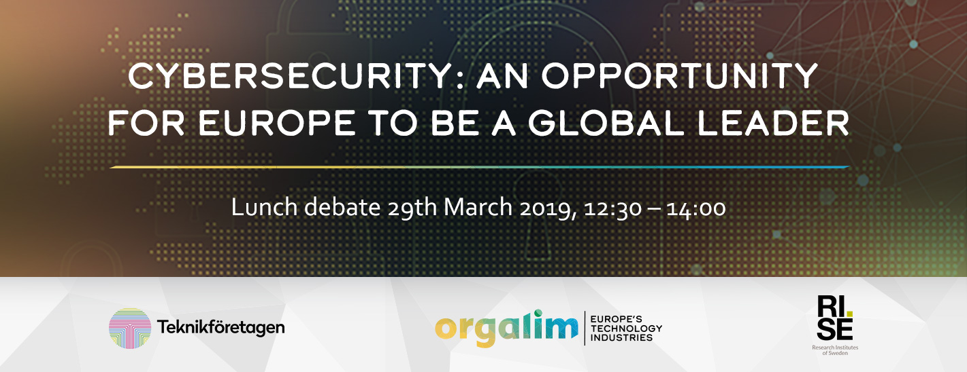

Organised by Orgalim, the Europe’s technology industries
and Teknikföretagen, the Swedish Association of Engineering Industries and Research Institutes of Sweden, RISE

Digital technologies are the backbone of Europe´s economy. It opens up opportunities for companies to develop new solutions and new businesses and for citizens to connect beyond borders.
At the same time, an increasingly interconnected society and economy increases the threat landscape. Cyberattacks and cybercrime are new challenges that requires action by all stakeholders and at all levels. Digitalisation profoundly affects our lives and businesses and cybersecurity is today already fundamental for business, consumers and citizens in general.
The European Commission has proposed a number of measures to build a stronger cybersecurity in the EU. The Cybersecurity Act is a part of such measures, reinforcing the mandate of the EU Agency for Cybersecurity, (European Union Agency for Network and Information and Security, ENISA) to support Member States with tackling cybersecurity threats and attacks. The Regulation also establishes a new EU-wide certification framework with the aim to boost the cybersecurity levels for products and services in the digital world in Europe and beyond.
Europe’s technology industries are fully committed to a strong cybersecurity in B2B and B2C markets – essentially for the whole (industrial) internet of things, (I)IoT. The Cybersecurity Act as a European approach is the right first step. Europe can, and should, set a global standard on cybersecurity – strengthening trust for citizens, companies and societies.
Nonetheless, too many diverging principles and rules applied to specific sector legislation could cause a patchwork of cybersecurity requirements in Europe. This would be ineffective and cost-inefficient and can even harm trust in general, undermining the core objective to boost Europe’s cybersecurity levels. As a second step, Europe could consider a horizontal approach for upcoming private or regulatory initiatives – at least when dealing with baseline security requirements.

Orgalim, together with Teknikföretagen and Research Institutes of Sweden, RISE invite you to debate how industry, ENISA and the European institutions could collaborate to develop a world leading and efficient cybersecurity system.

The debate will take place on 29th March 2018 at the Gothenburg European Office, rue Luxembourg, 3, in Brussels, starting at 12.30 (doors open at 12:00). A sandwich lunch will be offered.
Please confirm your participation by 20 March 2019, by sending your registration form to Charlotte Andersdotter, charlotte.andersdotter@teknikforetagen.se
Due to the limited capacity of the venue and as we are trying to welcome a balanced audience, we reserve the right not to accept all registrations.
We look forward to meeting you.
Best regards,
Klas Wåhlberg, Teknikföretagen Malte Lohan, Orgalim, Pia Sandvik, RISE

Registration form

Name: _________________________________________________________________
First Name: _____________________________________________________________
Organisation: ____________________________________________________________
Job Title: ________________________________________________________________
Email Address: ___________________________________________________________

Please tick the boxes you agree with:
☐ I hereby consent that my name, surname, title and e-mail address are shared with Orgalim, Teknikföretagen and RISE to organise this meeting.
☐ I hereby consent that my pictures are used by Teknikföretagen, Orgalim and RISE for communication. I understand that these images may appear publicly as part of Orgalim´s, Teknikföretagen ‘s and RISE´s website and/or other communication materials
☐ I hereby consent that my name, surname and title are published by Orgalim, Teknikföretagen and RISE for communication purposes. I understand that this information may be printed at the event.

Please confirm your participation by 20 March 2019, by sending your registration form to Charlotte Andersdotter, charlotte.andersdotter@teknikforetagen.se

Due to the limited capacity of the venue and as we are trying to welcome a balanced audience, we reserve the right not to accept all registrations.

